

**Faculty of engineering - Shoubra**

**Benha University**

|  |  |
| --- | --- |
| *Name* | *ahmed belal mosleh mohamed* |
| *Edu.Email* | [*ahmed195036@feng.bu.edu.eg*](mailto:ahmed195036@feng.bu.edu.eg) |
| *B.N* | *11* |
| *Course* | *Computer* |
| *Course code* | *ECE001* |
| *Date* | *2/6/2020* |
| *Topic* | *Operating system* |

**Application brief :**

**What is an Operating System?**

An **operating system** is the core set of software on a device that keeps everything together. **Operating systems** communicate with the device's hardware. They handle everything from your keyboard and mice to the Wi-Fi radio, storage devices, and display. In other words, an **operating system** handles input and output devices.

**The importance of operating system:**

An operating system (sometimes referred to as “OS” in the acronym) is a process, after the initial startup programs are loaded into the computer, management, computer, all the other programs. Other programs are called applications or application. The application makes use of the operating system through a defined application program interface (API) service request. In addition, the user can interact with the user interface operating system, such as direct command language or graphical user interface (GUI).

Operating system is system software, the computer work. We can say that an operating system (OS) is software and hardware interfaces for your behavior. It contains not only speak the language for hardware drivers, but also provide you with a very specific graphical user interface (GUI) to control the computer. An operating system can also be used as an interface (from the hardware) to other software. Like Windows or Linux or a Mac OS operating system provides a complex operating system services, but also has inch Solitaire, paint, Messenger build applications, are applied.

Application software is software that you install your operating system. It includes procedures, just let you use your computer things. These applications are run on various operating systems. These include like your word processing program, spreadsheet things, e-mail client, Web browser, games and many other programs, such as most of Microsoft’s Office suite is written in the Mac and Windows versions, but you still have to have your correct version of the operating system.

When an ISP’s preliminary consideration is to look at the type of access required. Some ISP only provides dial-up access, is the slowest type of connection. If you want cable service, you will check with your local cable provider to see if it is to provide cable access. For DSL service, you may have several options – or it may be DSL is not yet available in your area. Typically, this can be remedied by telephone calls to improve the local telephone company lines.

Each ISP has its own privacy policy and service (TOS) contract terms that users must agree to before subscription will be accepted. Privacy policy say the company will not with the personal information collected at the time of registration. Name, address, credit card number, is usually required. Privacy policy and under what conditions should also be your personal information with third parties may be, government officials or others to share state. Terms of service contract use of this service. For example, dial-up access is often sold “unlimited access”, but this is not literally. General limit per month dial-up accounts 250-400 hours, depending on ISP. The real unlimited access (to your computer and actively connected to the Internet 24 / 7) are called dedicated access. Most DSL or cable subscriptions allow dedicated access.

ISP services to the relevant provisions of the contract hackers rule also provides protection of copyrighted material, denial of service attacks, harassing other people, spam, damage to services, and many others. This is, most of the ISP’s protection of the law so that potential customers know that ISP will absolutely not be tolerated. If you are planning to use cyberspace ISP, is also limited in the checks here. Many ISP does not allow commercial sites are set up on the server. This usually means that nothing can be sold from your personal web space, including, for example, a software program, you say, original music, or any other items. ISP’s website often for personal use only, blog, post pictures, and more.

An operating system on multiple operating systems to share hardware resources solutions. We have presented its structure, and suggested using the Linux operating system for ix86-based implementation. We also defined the field of application. Although the discussion of the implementation focused around the use ix86 Linux, proposed concept can be extended to other structures and other basic operating system to provide the same functionality. Because the operating system market and the current state of research, advanced Earth observation satellites can be used between the two areas to provide a bridge to promote greater flexibility and cooperation in the development of the operating system. This will provide the necessary development of user-friendly operating environment, not by a single choice of operating systems limited the flexibility of the application system administrators and programmers.

An internet service provider: main purpose behind this directory is to help our site visitors who provide a great look on the Internet. We provide Internet access to the premium list will be your first choice. We list some of the most gaps in customer satisfaction according to our higher premium based on the list of rations ISP provider. ISP provider for the premiums we have an individual review pages.

Basically, we have our web site differ in two major parts: the broadband Internet and high dial-up Internet access. According to our broadband Internet prices you can find them together, planning, review and rating such as cable Internet, DSL providers, broadband wireless Internet service providers and low-cost supplier of ISDN provider

**Screenshots:**

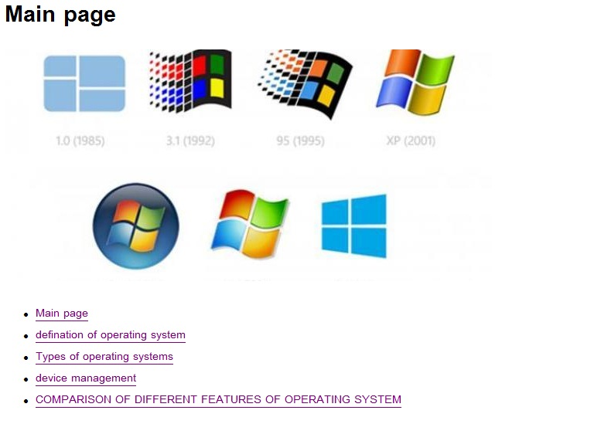

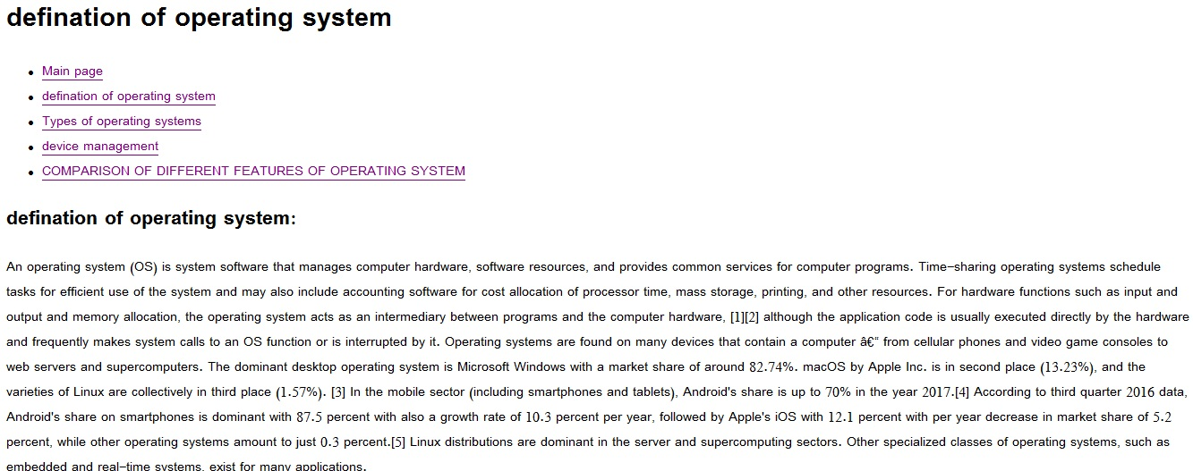

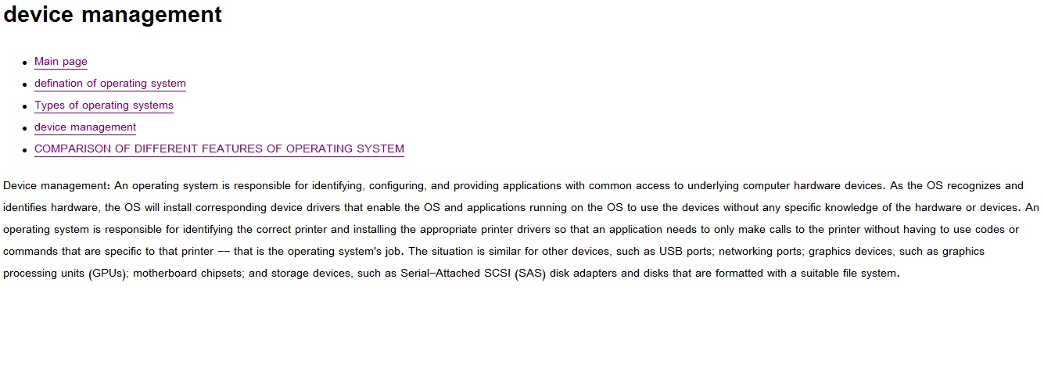

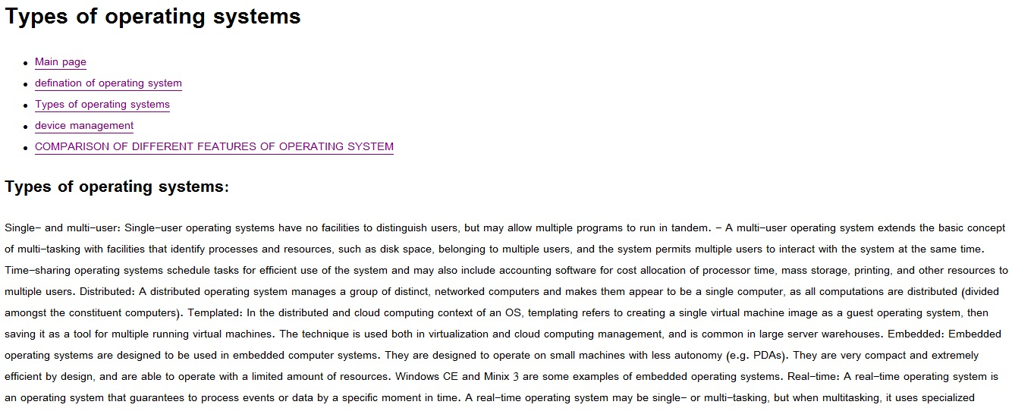

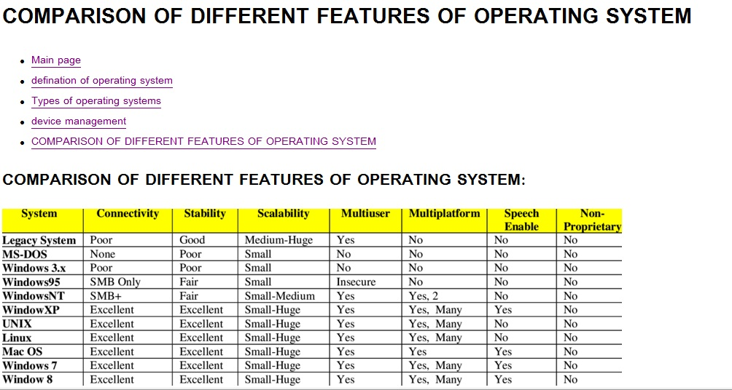

**Source Code:**

